

**Central bank asset purchases and financial markets**

Speech given by

David Miles, External Member of the Monetary Policy Committee, Bank of England

At the Global Borrowers & Investors Forum London

26 June 2013

I would like to thank Jochen Schanz and Arpad Morotz for research assistance, and others for helpful comments. The views expressed are my own and do not necessarily reflect those of the

Bank of England or other members of the Monetary Policy Committee.

The nature of the effects of large scale asset purchases by central banks is controversial, important and of immediate relevance to policy. I want to consider the evidence on the impacts of such asset purchases, assess whether they are causing distortions in financial markets – rather than provide support for demand in the wider economy – and offer some thoughts on how the exceptional setting of monetary policy we see in the UK today might ultimately be normalised.

Much of the most vocal and opinionated analysis of the impacts of central bank asset purchases – quantitative easing (QE) – strikes me as somewhat contradictory. Some people seem to believe that large scale asset purchases by central banks have created a bubble in many asset markets and that stopping such purchases (let alone reversing them) must cause big falls in prices. Others take the view that these central bank purchases are ineffective in stimulating demand in the wider economy. I think the evidence for either of these positions is weak. But some people believe both things – a position that I think is also contradictory as well as being profoundly pessimistic.

To make much headway it is important to be clear at the outset what a bubble is. Language matters. One must distinguish between the proposition that such asset purchases have made financial market prices higher than they would have been – which I think is true – and that such prices have been pushed far above what the economic fundamentals suggest is warranted, which is what a bubble is. My reading of the evidence suggests that it is more likely that central bank asset purchases have moved the prices of many private sector assets closer towards what the underlying economic conditions warrant rather than that they have driven prices far above such levels. I want to look at that evidence and also think about what the impact on the wider economy is of asset prices having been held up relative to where they might have been. I also want to look ahead to think about what might happen when monetary policy is once again normalised.

I do not think we should be in any hurry in the UK to move the monetary policy dials back to more normal settings – indeed it might well be right for the next move in the UK to push them even further to give more support to demand. But thinking about how policy will ultimately be normalised – and what the effects will be

– is essential in thinking about how far the dials should be pushed away from normal in the near term. I will come back to this later.

**Asset purchases and bubbles**

I think the claim that QE has artificially boosted the prices of many assets to bubble levels does not stand up. But it is true that in purchasing financial assets central banks – certainly the Bank of England’s Monetary Policy Committee – have deliberately and consciously raised the demand for these assets and that will have supported their prices. Supporting asset prices helps to support growth, because it means that many companies find it easier to raise funds and because it means that household borrowers face lower longer term interest rates. By keeping the value of portfolios of wealth higher than they would have been the spending of many people who own that wealth is supported. Does anyone doubt that many households

who, even given the recent sharp sell-off, have seen the value of their ISAs and other stocks and bonds rise over the past few years would have been less inclined to spend had these savings instead fallen sharply in value?

One of the ways that financial crises can have drawn out consequences is when debtors’ balance sheets deteriorate as the assets that they hold lose value. This runs the risk of a negative self reinforcing spiral – a worsening economic situation pushing down on asset prices further depressing demand. By supporting asset prices, QE has helped to ensure that this sort of negative spiral has not happened in the UK. There is a world of difference between supporting asset prices so as to prevent a self-reinforcing downward spiral in values and creating a bubble. Indeed preventing a downward spiral – because it stabilises both asset prices and the wider economy – is pretty much the opposite of blowing up a financial market bubble.

The evidence for a general bubble in asset prices is not very convincing. Before the very recent sharp falls, stock prices had risen strongly over the past year or so. A couple of weeks ago the FTSE All-Share index was about back where it was in the summer of 2007 – having fallen by about 40% between mid 2007 and early 2009. But in real (inflation-adjusted) terms stocks were still down by about 20% from the peak 2007 level (Figure 1). In real terms stock prices were at about the average level of the past 20 years.

**Figure 1: FTSE All Share, real, indexed to January 2007 = 100**

120

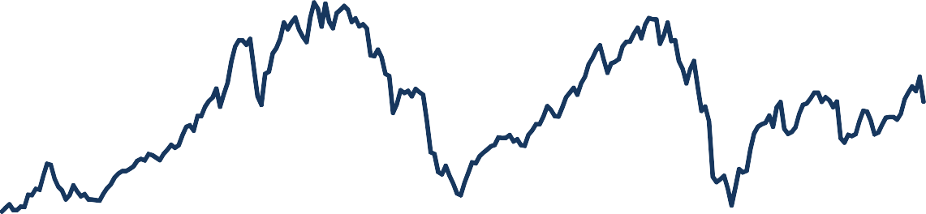

100

80

60

40

20

0

1993

1994

1995

1996

1997

1998

1999

2000

2001

2002

2003

2004

2005

2006

2007

2008

2009

2010

2011

2012

2013

Sources: Bloomberg, ONS, Bank calculations

Notes: FTSE All-Share index, monthly averages, January 2000 prices (CPI-adjusted), indexed to January 2007. Last data point: estimated for June 2013 from FTSE All-Share data up to 21 June, deflated using the Bank of England CPI forecast of 3.1% for June 2013 from the May 2013 *Inflation Report .*

Price to earnings ratios on those stocks do not look unusually high. Figure 2 shows that PE ratios are currently significantly below the average in the ten year period leading up to the crisis of 2007-08. That specific ten year period may have been one in which stock prices were somewhat inflated; but current PE ratios – even before the stock market sell off of the past few weeks – are still no higher than averages over much longer periods covering several decades.

**Figure 2: Price to earnings ratios of UK and US and German equities**

Ratio

# 40

UK

US

Germany

35

30

25

20

15

10

5

0

Source: Datastream.

Note: The price to earnings ratios are calculated from equity indices maintained by Datastream, using average earnings over the past 5 years.

Were there to be a bubble in stock prices I would also expect the equity risk premium – the gap between expected returns on a portfolio of stocks and on safe bonds – to have declined to exceptionally low levels. Although we cannot measure the equity risk premium accurately, estimates based on a dividend discount model suggest the risk premium on stocks in the FTSE index is actually substantially above the average of recent decades (Figure 3).

**Figure 3: UK equity risk premium**

8

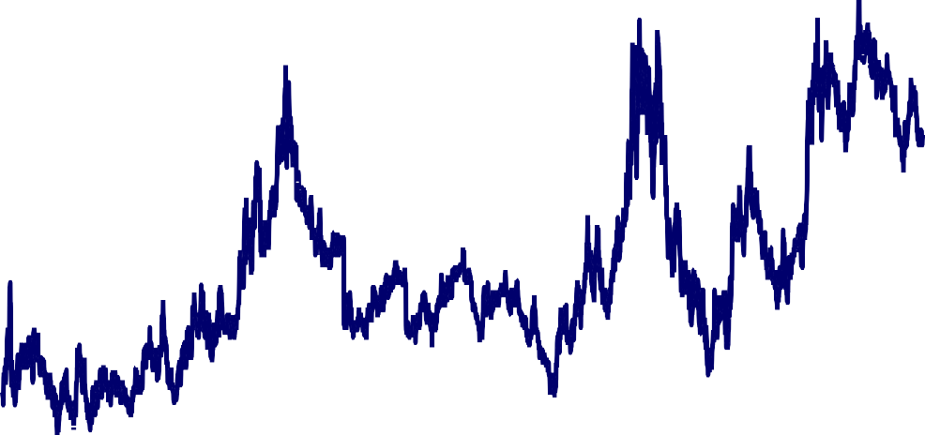

Equity risk premium

25/75 percentiles (since 1998) Average 1998‐2013

7

6

5

per cent

4

3

2

Sources: Thomson Reuters Datastream and Bank calculations.

Notes: FTSE All-Share. The equity risk premium is inferred from a dividend discount model. For further details, see M. Inkinen,

M. Stringa and K. Voutsinou (2010), ‘Interpreting equity price movements since the start of the financial crisis’, Bank of England Quarterly Bulletin, Vol. 50, No. 1, pages 24–33. Last data point is 12 June 2013.

What about UK house prices? Average house prices in the UK are – according to some national measures – only 5-10% lower than at the end 2007 peak. Different indices of house prices tell somewhat different stories. But in real terms, that is adjusted for the general rise in the price of goods, they are all down very substantially. Some measures are down by about 30% in real terms; some are down by about 25%; some measures of house prices in England and Wales (which exclude Northern Ireland where prices are down dramatically) are, in nominal terms, more or less where they were at the end 2007 peak – but even they are some 20% lower in real terms. Deflating house prices by an index of disposable incomes shows much the same picture: average house prices relative to average disposable incomes are down by between 20% and 30% from peak levels (See Figures 4 and 5).

**Figure 4: Real house prices, deflated by RPI, Q3 2007 = 100**

120

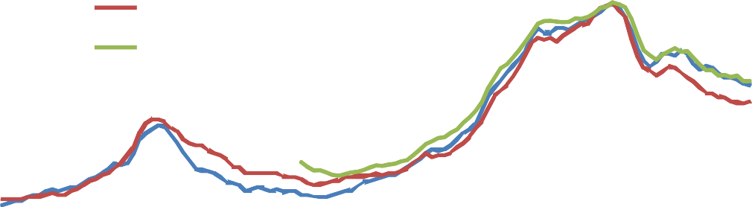

Nationwide

Halifax

Land Registry

100

80

60

40

20

0

1983 Q1 1988 Q1 1993 Q1 1998 Q1 2003 Q1 2008 Q1 2013 Q1

Sources: Halifax, Land Registry, Nationwide , ONS, Bank calculations.

Note: Real series based on RPI. Halifax and Nationwide series are for the UK. The Land Registry series covers England and Wales only.

**Figure 5: House prices, deflated by disposable household income, Q3 2007 = 100**

120

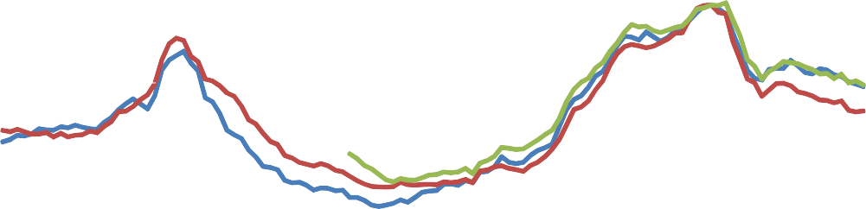

Nationwide

Halifax

Land Registry

100

80

60

40

20

0

1983 Q1 1988 Q1 1993 Q1 1998 Q1 2003 Q1 2008 Q1

Sources: Halifax, Land Registry, Nationwide , ONS, Bank calculations.

Note: Nominal series deflated by per capita nominal disposable household income. Halifax and Nationwide series are for the UK. The Land Registry series covers England and Wales only.

Yields on UK government debt – both in nominal and real terms – are unusually low (Figures 6 and 7). That is true even after the recent sharp sell-off in gilts following re-assessment of the Fed’s likely scale of asset purchases. Part of the low level of gilt yields reflects a belief that the Bank of England is likely to keep Bank Rate at relatively low levels for some time yet. Part of it is likely to reflect a substantially higher perceived level of risk now relative to before the financial train wreck of 2007-8. That puts a premium on relatively safe assets like gilts. So there are good reasons why yields on safe government bonds should be low today. I think some people are far too quick to label this a “bubble” – which I would define as a level of prices far removed from what can be expected given the fundamental economic forces at work in the wider economy.

The fact is that with output remaining depressed relative to activity levels before the crisis of 2007-08 and with inflation close to target in many countries central banks are not expected to raise the short term rates they control back to pre-crisis levels for some time. It is seen as likely that short term nominal interest rates for years to come will remain below levels considered normal in the years before the financial crisis. So we should expect to see forward rates implied by the prices of government bonds well below pre-crisis levels for some years ahead – which is precisely what we see in the UK. But looking more than 7 or so years down the road the forward rates now on gilts – which are a guide to expectations on where Bank Rate might then be – are not very different from what they were at the start of 2007. At that time the forward rate relevant to 2021 (which in 2007 was a 14 year forward rate) was about 4%, which is close to today’s forward rate for 2021. In fact longer term forward rates are higher now than in early 2007, before the crisis. Shifts in term premia make it hard to certain how to interpret all this, but the idea that there is clearly a bubble in the gilts market does not really stand up.

**Figure 6: UK nominal instantaneous forward yield curves**

6

15 February 2007

16 February 2009

20 June 2013

5

4

3

Per cent

2

1

0

0 2.5 5 7.5 10 12.5 15 17.5 20 22.5 25

Years

Sources: Bloomberg LLP and Bank of England calculations.

Note: Zero-coupon yield. Derived from the Bank’s government liability curves.

**Figure 7: UK real instantaneous forward yield curves**

3

2.5

2

1.5

1

Per cent

0.5

0

‐0.5

‐1

‐1.5

‐2

15 February 2007

16 February 2009

20 June 2013

0 2.5 5 7.5 10 12.5 15 17.5 20 22.5 25

Years

Sources: Bloomberg LLP and Bank of England calculations

Note: Zero-coupon yield. Derived from the Bank’s government liability curves, based on RPI index-linked gilts.

For corporate bonds there is even less evidence of a bubble. Instead what we have seen in recent years is a partial reversal of the dramatic rises in the spread of yields over gilts that came in the immediate aftermath of the financial crisis (figure 8). That collapse in the price of corporate bonds in early 2009 has been followed by a recovery – though an uneven one – in market prices. Values of corporate bonds recovered strongly from the Spring of 2009 as the Bank of England and other central banks cut policy rates to near zero and then bought huge quantities of government bonds, stimulating demand for corporate debt. Spreads on corporate bonds widened out again in 2011 – which was one of the reasons for the Bank of England resuming asset purchases. Since then corporate bond spreads have moved lower. But the spread between corporate bond yields and yields on government bonds remains wider than it was before the financial crisis.

Figure 9 shows a decomposition of that spread which attempts to identify the part due to illiquidity and uncertainty and a part due to expectations of losses on corporate debt. The component due to illiquidity and uncertainty still appears unusually high – suggesting that bond prices still remain somewhat depressed. This is hardly a bubble.

**Figure 8: Sterling corporate bond spreads for financials, non-financials and high yield**

Bas 3500

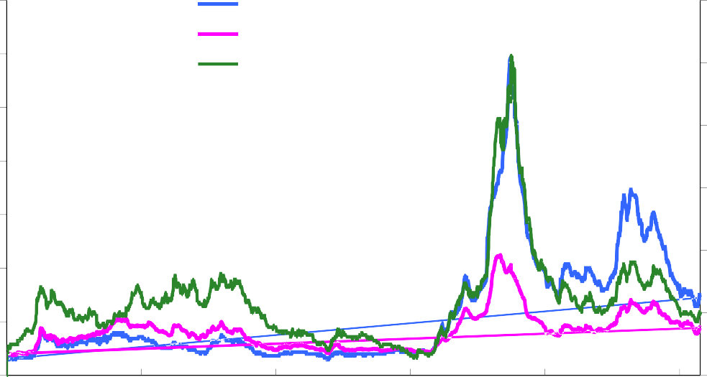

is points

Bas

Financials (rhs)

Non‐financials (rhs) High yield (lhs)

3000

is points 1200

1000

2500

2000

1500

1000

500

800

600

400

200

0 0

1998 2001 2004 2007 2010 2013

Source: Bank of America Merrill Lynch

Note: Option-adjusted spread over government rates.

**Figure 9: Decomposition of sterling investment-grade corporate bond spreads**

Basis points

# 750

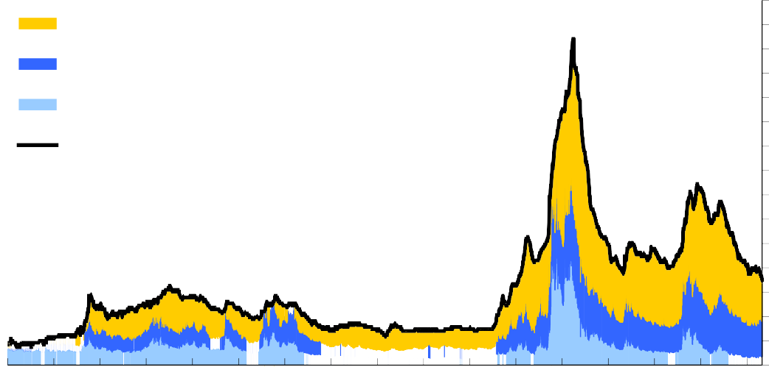

Residual (including compensation for illiquidity) Compensation for uncertainty about default losses Compensation for expected default losses

Actual

700

650

600

550

500

450

400

350

300

250

200

150

100

50

0

97 98 99 00 01 02 03 04 05 06 07 08 09 10 11 12 13

Sources: Bloomberg, Merrill Lynch, Thomson Datastream and Bank calculations.

Note: Webber, L and Churm, R (2007), 'Decomposing corporate bond spreads', Bank of England Quarterly Bulletin, Vol. 47, No. 4, pages 533-41. Option-adjusted spreads over government bond yields.

**Asset prices and the wider economy**

What is one to make of the uniquely pessimistic, but increasingly widespread, view that QE has both created multiple asset bubbles while having no impact in boosting demand in the economy? What I find implausible about this is the idea that a rise in the value of assets, and a fall in the likely future return on savings, could have no effect on stimulating someone’s spending. You would have to believe that investment was not at all responsive to a greater availability of funding at a lower required return. Is that really plausible?

You would also need to believe that the wealth effect – that is the positive impact on confidence and spending that higher wealth brings – does not work. I can certainly believe that there are some people who would not respond to higher asset prices by spending more. For some young people the higher value of their existing assets could be more than offset by the prospect of lower returns on future savings which meant they might need to save more to hit a target for wealth far in the future. But I suspect such households are in a small minority. A more common response to the annual statement showing that an ISA or unit trust was worth more than you might have expected is to spend some of the unanticipated gain. That is what simple economic theory suggests would be the response of older households, and they own far more wealth than younger people.

All in all, I think there is a far more plausible, and rather less sensational, view on the effects of QE. This is that it has supported a wide range of asset prices and that this has caused spending to be higher than it would otherwise have been.

**Unwinding QE**

What will happen when the asset purchases begin to be unwound? Will the impact on growth and inflation be as large as it had been when the Bank of England purchased assets, just with the opposite sign? I think there are reasons to doubt that, as I will explain shortly. But for the moment let us suppose that this was the case, and that the MPC decided that monetary policy should be tightened. Then asset purchases would be unwound very gradually, corresponding to the degree of tightening that appears appropriate at the time. So even if growth and inflation were to respond strongly to gilt sales, this is not in itself a problem for monetary policy. The Bank would then adjust the speed of sales accordingly.

But there are good reasons to believe that growth and inflation may respond less to selling gilts than they did to gilt purchases. QE had a considerable impact during the crisis because financial markets were not functioning well. This meant that large-scale purchases of gilts were able to boost the prices on some assets

– corporate bonds in particular – because they came at a time when those markets were in a downward spiral which they helped reverse. It is likely that when bond purchases are reversed financial markets will be working more normally. In more normal markets portfolio changes could be expected to have much less of a

price impact because arbitrage and substitutability will be more powerful than when markets are segmented under stressed conditions.

Together with a colleague at the Bank, I am attempting to obtain a clearer idea about how strong the impact of sales of gilts might be in an environment where there are no limits to arbitrage, and where investors look across all asset classes when deciding which investment strategy to adopt. The only departures we allow from the complete, perfect markets paradigm is that investors are subject to borrowing constraints. Our initial results using a simple model suggest that when financial markets are working well even quite large changes in portfolios generated by central bank transactions might cause limited changes in prices.

The model that we are developing is highly stylised and makes many simplifications. For example, it abstracts from institutional frictions which might mean that the capacity of markets to absorb large amounts of gilt sales in a short period is likely to be limited. But the initial results appear to suggest that purchasing assets in times where financial markets are dysfunctional, and selling them when markets work well, might well be part of an optimal monetary policy strategy.

And the unwinding of the Bank’s asset purchases is indeed likely to occur when financial markets are operating more normally. In this environment, investors are much more likely to exploit a perceived difference between the long rate and expected short rates. Risks involved in such trades are also likely to be lower because investors will have a better idea about the total amount of the central bank’s gilt sales than they had about the total amount of gilt purchases during the crisis. That could mean that asset purchases are made when the impact on asset prices and demand in the wider economy is relatively large but assets are sold when the effects on asset prices and demand are much smaller.

Furthermore, it is not clear that the Bank of England’s balance sheet will ultimately shrink to where it had been before the crisis. Banks have learnt that they took excessive liquidity risks before the crisis, and, independently of tighter regulation, are likely to want to hold substantially higher levels of liquid assets in future. Some of these assets are likely to be held in the form of central bank reserves. A natural asset for the central bank to hold to balance the increased amount of commercial bank reserves are government bonds. So it is very far from clear that returning monetary policy to a normal setting means that the Bank of England balance sheet will shrink back to where it was before the crisis.

Figure 10 shows just how small were the most liquid of assets held by banks before the crisis. Even now – after a huge expansion of reserve balances held by banks at the Bank of England – levels of the most liquid banks’ assets (reserves and gilts) relative to bank balance sheets are far smaller than was normal in the 1970s and before. Even if banks only went a small part of the way towards holding portfolios of liquid assets that were considered normal some decades ago, they would be holding far more such assets than was the case before the Bank of England started QE and commercial bank reserves increased sharply.

**Figure 10: Sterling liquid assets relative to total asset holdings of UK banking sector (a) (b)**

35

Broad ratio(c)

Reserve ratio(d) Narrow ratio(e)

30

Percentage of total assets

(all currencies)

25

20

15

10

5

0

1968 73 78 83 88 93 98 2003 08 13

Sources: Bank of England and Bank calculations. Notes:

1. Data for building societies are included from 2010 onwards. Prior to this, data are for UK banks only.
2. Data are end-year except for 2013 where end-April data are used.
3. Cash + Bank of England balances + money at call + eligible bills + UK gilts.
4. Proxied by: Bank of England balances + money at call + eligible bills.
5. Cash + Bank of England balances + eligible bills.

**Conclusions**

* 1. The evidence that asset purchases by central banks have caused generalised bubbles in financial asset prices is weak.
  2. In the UK there is more evidence that the Bank’s asset purchases helped to stop an anti-bubble, that is, a downward spiral in asset prices that would have further damaged the real economy and become dangerously self-reinforcing.
  3. The market environment in which an unwind of asset purchases takes place is crucial; if done when financial markets are functioning normally a gradual unwind may be smooth.
  4. In the UK the unwind of the huge expansion of the central bank balance sheet need not be complete because commercial banks will be very likely to want to hold more reserves than the tiny sliver that they thought adequate before the financial train wreck.